 

**Faculty of Computers and Artificial Intelligence**

**Cairo University**

**Graduation Project**

Text to Art Generator

|  |  |
| --- | --- |
| Name | ID |
| Alaa Reda | 20170449 |
| Aya Sabry | 20180354 |
| Eman Salah | 20180063 |
| Gehad Mostafa | 20180080 |
| Omnia Mohamed | 20180056 |
| Rana Mohamed | 20180104 |

Supervised by:

**Dr. Motaz El Saban**

**March 2022**

Table of Contents

1. Introduction 5

2. Scope 5

3. objectives 5

4. Datasets 5

5. Problems 5

6. Recent applications 6

7. Related Work with some comparisons 7

7.1. VQ-VAE 7

*Comparison between VQVAE and our model* 8

7.2. GLIDE 9

8. Generative Models 10

Generative learning trilemma: 10

8.1. Generative Adversarial Networks (GANs) 11

**8.1.1.** **What are Generative Adversarial Networks** 11

**8.1.2.** **The GAN Architecture** 12

**8.1.3.** **GAN Training Process** 14

**8.1.4.** **GAN Applications** 15

8.2. Variational Autoencoders (VAEs) 16

**8.2.1.** **Autoencoders** 16

**8.2.2.** **Definition of Variational Autoencoders** 17

8.3. Flow-based Deep Generative Models 18

8.4. Diffusion Models 19

**8.4.1.** **Forward Process** 21

**8.4.2.** **Reconstruction** 22

**8.4.3.** **Training and Results** 23

Our model 25

9. VQ-GAN 25

9.1. What is VQGAN? 25

9.2. VQGAN Architecture 25

9.3. Using Transformers to model interactions 26

9.4. Expressing images through a codebook 27

9.5. Putting it all together 28

10. Transformers 31

10.1. Introduction to Taming transformer 31

10.2. Methodology of the transformers 31

**10.2.1.** **Training of GAN** 32

**10.2.2.** **Training the transformer** 34

10.2.3. Transformer loss 34

10.2.4. Generating High-Resolution Images: 35

11. Clip (Contrastive Language Image Pre-training) 37

11.1. Transfer Learning 37

11.2. Zero-shot Learning 37

**The importance of Zero-Shot Learning:** 38

11.3. Introduction To CLIP Model 39

11.4. How CLIP Works? 41

11.5. Clip Approach 44

**11.5.1.** **Contrastive pre-training** 44

**11.5.2.** **The image encoder** 44

**11.5.3.** **The text encoder** 45

**11.5.4.** **The multi-modal embedding space** 45

**11.5.5.** **Create dataset classifier from label text** 46

**11.5.6.** **Use for zero-shot prediction** 46

**11.5.7.** **Result** 47

11.6. Advantages of CLIP 48

11.7. CLIP Problems 49

11.8. Use Cases of CLIP 49

• **Image classification** 49

• **Image Generation** 49

• **Image Search** 50

• **Robotics Control** 50

• **Image Captioning** 50

• **Deciphering Corrupted Images** 50

• **Object Tracking** 50

11.9. CLIP Model Hyperparameters 51

11.10. What is VQGAN+CLIP? 52

11.11. The Metric of our model 53

12. Sentence Bert 53

12.1. Introduction to Sentence-Bert 53

12.2. Experiment-Semantic Textual Similarity (Unsupervised-STS) 55

12.3. Monolingual Sentence Embeddings Multilingual using Knowledge Distillation 56

12.4. The proposed knowledge distillation procedure 56

12.5. Multilingual Joint Image & Text Embeddings 58

12.6. Training 58

13. Create video: 58

14. Next Step 58

15. References 60

Table of Figures

**Figure ‎6.1: Structure of Deep Dream** 6

**Figure ‎7.1: Output of DALL-E Model** 7

**Figure ‎0.1: Architecture of GAN.** 12

**Figure ‎0.2: The two GAN subnetworks.** 13

**Figure ‎0.3: Training of Discriminator** 14

**Figure ‎0.4: Training of Generator.** 15

**Figure ‎9.1: A convolutional neural network feature map showing features at different levels.** 26

**Figure ‎9.2: A CNN can learn high-level features that we refer to as visual parts.** 27

**Figure ‎9.3: Vector quantization finds the representative centroids for each cluster.** 28

**Figure ‎9.4: Quantization of output of CNN + Transformer network.** 29

**Figure ‎9.5: Instead of CNN we use GAN** 30

**Figure ‎10.1: This approach learns a codebook of context-rich visual parts.** 32

**Figure ‎10.2: The GAN’s generator contains an autoencoder network.** 32

**Figure ‎10.3: Representing images in a sequence corresponding to the codebook indices of their embeddings.** 34

**Figure ‎10.4: Training the transformer is done via next-word prediction like languages.** 34

**Figure ‎10.5: Encoder and decoder are trained in the first stage as a VQGAN.** 35

**Figure ‎10.6: When sampling images, VQGAN used sliding attention to different patches.** 35

**Figure ‎11.1: Zero-Shot Learning Process** 38

**Figure ‎11.2: Example of semantic embedding using an attribute vector.** 39

**Figure ‎11.3: The pre-training phase.** 41

**Figure ‎11.4: Cosine Similarity Formula.** 42

**Figure ‎11.5: CLIP as Classifier after Training.** 43

**Figure ‎11.6: CLIP is much more efficient at zero-shot transfer.** 44

**Figure ‎11.7: Zero-shot prediction.** 47

**Figure ‎11.8: Predictions of zero-shot CLIP classifiers on examples from various datasets.** 48

**Figure ‎11.9: Common CLIP hyperparameters** 51

**Figure ‎11.10: CLIP-ResNet hyperparameters.** 51

**Figure ‎11.11: CLIP-ViT hyperparameters.** 52

**Figure ‎11.12: The VQGAN model generates images while CLIP guides the process.** 53

**Figure ‎12.1: Teacher-Student Model** 57

# **Introduction**

The AI art apps generate images by simply typing a brief description of what we want to see, no matter what we type, the app will generate something visually compelling that matches our prompt in often surprisingly opposite ways. This sort of AI-generated artwork is becoming higher quality and more accessible. Past examples of these sorts of text-to-image models have included research-orientated programs like DALL-E and VQGAN+CLIP, as well as more specialized commercial projects like Art breeder (which is particularly good at creating portraits of fictional beings and people). Generally, programs like these are trained on vision datasets — huge libraries of images that are tagged based on objects and scenery.

# **Scope**

We focus on model architecture and learning paradigms to learn more about the strengths and weaknesses of generative models applied in text-to-image. We also try to organize these works to show development over the years. Also, we mention top-powered tools and applications that are used at present. Finally, we emphasize existing and future challenges.

# **objectives**

Images are more attractive compared to text. Visual aids can deliver information more directly. Visual content grabs the attention and keeps people engaged. Key activities such as presentation, learning, and all involve visual Communication to some degree. If designed well, it offers numerous benefits.

# **Datasets**

1. vqgan_imagenet_f16_1024
2. vqgan_imagenet_f16_16384
3. vqgan_gumbel_f8
4. Parallel Sentences Dataset is used for multilingual training

# **Problems**

Image captioning and segmentation have been widely explored, the reverse problem of image generation from text captions remains a difficult task.

# **Recent applications**

**Dream App** is one of the latest techniques in the art of artificial intelligence. The Dream app takes things a step further with its speed, quality, and accessibility. It's available on iOS, Android, and the web. Huge libraries of images tagged based on objects and scenes. Programs choose consistent patterns and themes in these images and then use this information to try to create something that matches the users' claims. It includes a large selection of images - able to create images corresponding to the characters of cartoons, video games, and more. As a result, the app is used in novels, games, comics, and other projects and it has many releases such as:

1. **DEEP DREAM:**

Initially, it was invented to help scientists and engineers to see what a deep neural network is seeing when it is looking at each image. Later the algorithm has become a new form of psychedelic and abstract art.

* **Structure:**

Inception was trained on ImageNet, a famous dataset of pictures labeled with classes. 1000 classes exist in the dataset: cat, elephant, phone, house... but it is mostly cats and dogs...

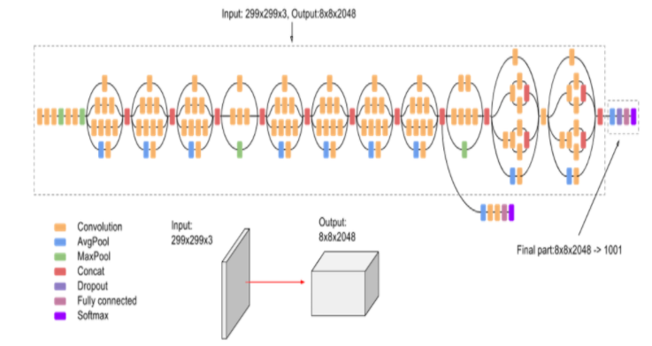

**Figure ‎6.1: Structure of Deep Dream**

1. **THIN STYLE:**

This tool is a simplified version of the Deep Style one. It is not capable of creating advanced transformations, but it still shines with some exceptional results. It is also noticeably faster than the Deep Style.

1. **DEEP STYLE:**

The technique is a much more advanced version of the original Deep Dream approach. It can use its knowledge to interpret a painting style and transfer it to the uploaded image.

# **Related Work with some comparisons**

## VQ-VAE

* **DALL·E:** It is a trained neural network called DALL E that creates images from textual comments for a wide range of concepts that can be expressed in natural language. It is a 12-billion parameter version of GPT-3 trained to generate images from text descriptions, using a dataset of text-image pairs.
* It has a diverse set of capabilities, including creating anthropomorphized versions of animals and objects, combining unrelated concepts in plausible ways, rendering text, and applying transformations to existing images.
* GPT-3, DALL E is a language model converter. It receives both text and image as a single stream of data containing up to 1280 symbols and is trained with maximum probability to generate all symbols, one by one.
* Images are processed with a resolution of 256 x 256 during training. Like VQVAE, each image is compressed into a 32 × 32 grid of discrete latent symbols using a discrete VAE pre-trained using continuous relaxation. Like reviving dead code, it can reach large vocabulary sizes.
* This training procedure allows DALL E to not only create an image from scratch but also to regenerate any rectangular region of an existing image that extends to the lower right corner, in a manner consistent with the text vector.

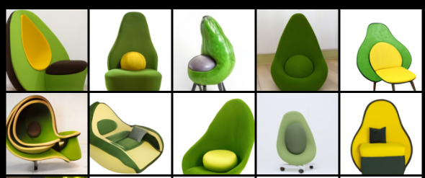

**Figure ‎7.1: Output of DALL-E Model**

# **Comparison between VQVAE and our model**

**Aleph using DALL-e (VQVAE) VS Our model (VQGAN+Clip):**

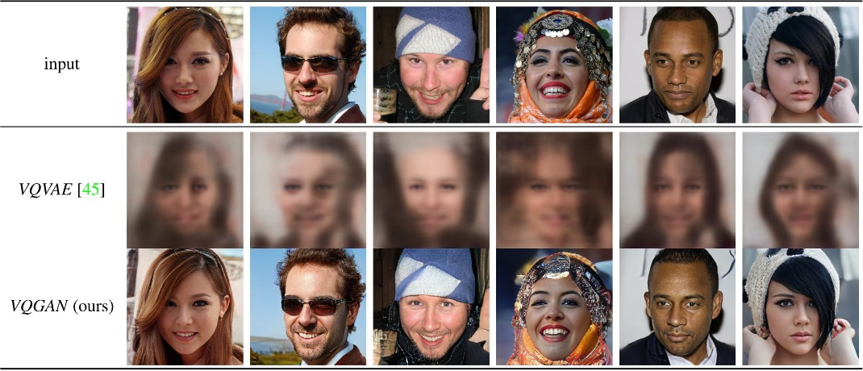

Comparing the ability of VQVAEs and VQGANs to learn perceptually rich encodings, which allow for high-fidelity reconstructions with large factors f. Here, using the same architecture and f = 16, VQVAE reconstructions are blurry and contain little information about the image, whereas VQGAN recovers images faithfully.

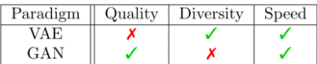

Speed” stands for sampling speed (not training speed).

VAE’s sampling speed is based on the ones without discrete bottlenecks.

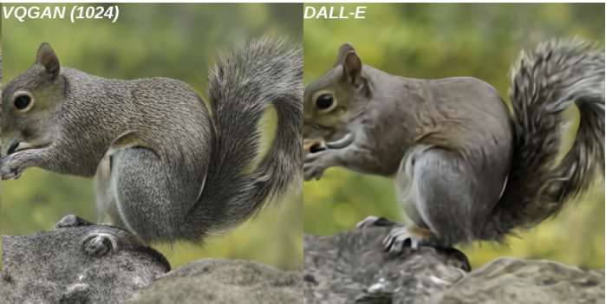

VQGAN vs. DALL-E. This shows that VQGAN’s training, the use of discriminator, leads to sharper samples.

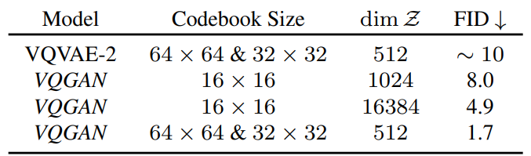

Reconstruction FID on ImageNet. This shows that VQGAN achieves substantially better FID for a given budget of codebook size, which roughly determines the per-sample computes for the model of the same size.

## GLIDE

* **GLIDE**: (Language-to-image guiding diffusion for creation and editing). This diffusion model achieves a similar performance to that of DALL-E despite using only one-third of the parameters.
* In addition to producing images from text, GLIDE can be used to alter existing images using natural language text prompts to insert new objects, add shadows and reflections, perform the internal drawing of images, and so on. It can also convert basic line drawings into realistic images and has powerful capabilities for zero sampling and repair for complex conditions.

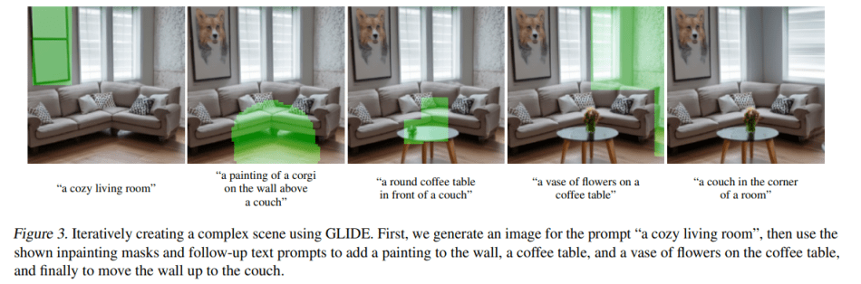

**Figure 7.2: Iteratively creating a complex scene using GLIDE.**

# **Generative Models**

* Generative models are a class of machine learning methods that learn a representation of the data they are trained on and model the data itself.
* Generative models are widely used for image synthesis and various image-processing tasks, such as editing, inpainting, colorization, deblurring, and super resolution.
* Generative models allow to synthesize novel data that is different from the real data but still looks just as realistic. A designer could train a generative model on images of cars and then let the resulting generative AI computationally dream up novel cars with different looks, accelerating the artistic prototyping process.
* There are Four types of generative models, GAN, VAE, Flow-based models, and Diffusion models. They have shown great success in generating high-quality samples, but each has some limitations of its own.

1. **GAN models** are known for potentially unstable training and less diversity in generation due to their adversarial training nature.

2. **VAE** relies on a surrogate loss.

3. **Flow models** have to use specialized architectures to construct reversible transform.

4. **Diffusion models** are inspired by non-equilibrium thermodynamics. They define a Markov chain of diffusion steps to slowly add random noise to data and then learn to reverse the diffusion process to construct desired data samples from the noise. Unlike VAE or flow models, diffusion models are learned with a fixed procedure and the latent variable has high dimensionality (same as the original data).

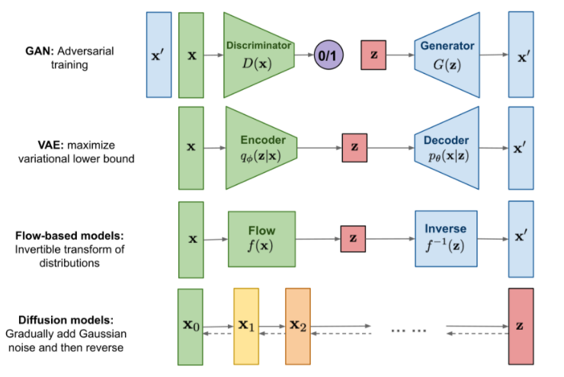

**Figure 8.1: Overview of different types of generative models.**

# **Generative learning trilemma:**

For a wide adoption in real-world applications, generative models should ideally satisfy the following key requirements:

1. **High-quality sampling:** Many applications, especially those directly interacting with users, require high generation quality. For example, in speech generation, poor speech quality is difficult to understand. Similarly, in image modeling, the desired outputs are visually indistinguishable from natural images.
2. **Mode coverage and sample diversity:** If the training data contains a complex or large amount of diversity, a good generative model should successfully capture such diversity without sacrificing generation quality.
3. **Fast and computationally inexpensive sampling:** Many interactive applications require fast generation, such as real-time image editing.

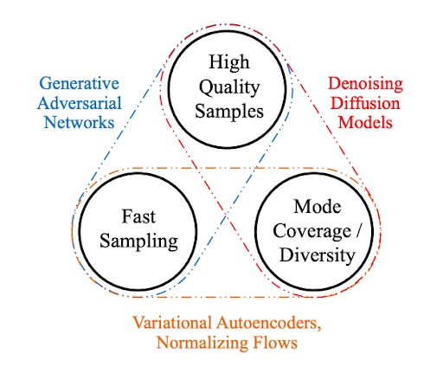

## Generative Adversarial Networks (GANs)

### **What are Generative Adversarial Networks**

* **Generative Adversarial Networks (GANs)** are a class of machine learning techniques that consist of two simultaneously trained models: one (the Generator) trained to generate fake data, and the other (the Discriminator) trained to discern the fake data from real examples.
* **Generative Adversarial Networks (GANs)** are types of neural network architectures capable of generating new data that conforms to learned patterns.
* **GANs** can be used to generate images of human faces or other objects, to carry out text-to-image translation, to convert one type of image to another, and to enhance the resolution of images (super-resolution) among other applications. Because GANs can generate entirely new data, they are at the head of many cutting-edge AI systems, applications, and research.

### **The GAN Architecture**

* Generative Adversarial Networks are built out of a **generator** model and **discriminator** model put together.
* The job of the **generator** model is to **create new examples of data**, based on the patterns that the model has learned from the training data.
* The job of the **discriminator** model is to analyze images (assuming it is trained on images) and **determine if the images are generated/fake or genuine.**

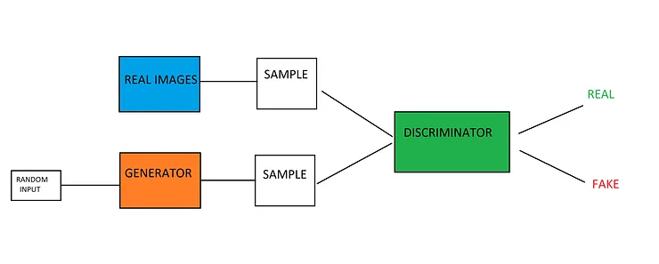

**Figure ‎0.1: Architecture of GAN.**

* There is a double feedback loop in play, as the ground discriminator is fed the ground truth of the images, while the generator is given feedback on its performance by the discriminator.
* The generative and discrimination models are playing a zero-sum game with each other. A zero-sum game is one where the gains by one side come at the cost of the other side (the sum is both actions is zero exes).
* When the discriminator model can successfully distinguish between real and fake examples, no changes are made to the parameters of the discriminator. However, large updates are made to the model’s parameters when it fails to distinguish between real and fake images. The inverse is true for the generative model, it is penalized (and its parameters updated) when it fails to fool the discriminative model, but otherwise, its parameters are unchanged (or it is rewarded).
* Ideally, the generator can improve its performance to a point where the discriminator cannot discern between the fake and real images. This means that the discriminator will always be rendering probabilities of %50 for real and fake images, meaning the generated images should be indistinguishable from the genuine images. In practice, GANs typically won’t reach this point. However, the generative model doesn’t need to create perfectly similar images to still be useful for the many tasks GANs are used for.



**Figure ‎0.2: The two GAN subnetworks.**

**Let’s walk through the details of the diagram:**

1. Training dataset: The dataset of real examples that we want the Generator to learn to emulate with near-perfect quality. In this case, the dataset consists of images of handwritten digits. This dataset serves as input (x) to the Discriminator network.
2. Random noise vector: The raw input (z) to the Generator network. This input is a vector of random numbers that the Generator uses as a starting point for synthesizing fake examples.
3. Generator network: The Generator takes in a vector of random numbers (z) as input and outputs fake examples (x*). Its goal is to make the fake examples it produces indistinguishable from the real examples in the training dataset.
4. Discriminator network: The Discriminator takes as input either a real example (x) coming from the training set or a fake example (x*) produced by the Generator. For each example, the Discriminator determines and outputs the probability of whether the example is real.
5. Iterative training/tuning: For each of the Discriminator’s predictions, we determine how good it is—much as we would for a regular classifier—and use the results to iteratively tune the Discriminator and the Generator networks through backpropagation:

* The Discriminator’s weights and biases are updated to maximize its classification accuracy (maximizing the probability of correct prediction: x as real and x* as fake).
* The Generator’s weights and biases are updated to maximize the probability that the Discriminator misclassifies x* as real.

### **GAN Training Process**

* **Let’s look at the entire training process for a hypothetical image generation task:**
* To begin with, the GAN is trained using genuine, real images as part of the training dataset. This sets up the discriminator model to distinguish between generated images and real images. It also produces the data distribution that the generator will use to produce new data.
* The generator takes in a vector of random numerical data and transforms them based on the Gaussian distribution, returning an image. These generated images, alongside some genuine images from the training dataset, are fed into the discriminator model. The discriminator will render a probabilistic prediction about the nature of the images it receives, outputting a value between 0 and 1, where 1 is typically authentic images and 0 is a fake image.



**Figure ‎0.3: Training of Discriminator**



**Figure ‎0.4: Training of Generator.**

### **GAN Applications**

GANs have several different applications, most of them revolving around the generation of images and components of images. GANs are commonly used in tasks where the required image data is missing or limited in some capacity, as a method of generating the required data. Let’s examine some of the common user’s cases for GANs:

1. **Generating New Examples for Datasets:** GANs can be used to generate new examples for simple image datasets. If you only have a handful of training examples and need more of them, GANs could be used to generate new training data for an image classifier, generating new training examples at different orientations and angles.
2. **Generating Unique Human Faces:** When sufficiently trained, GANs can be used to generate extremely realistic images of human faces. These generated images can be used to help train face recognition systems.
3. **Image-To-Image Translation:** GANs excel at image translation. GANs can be used to colorize black and white images, translate sketches or drawings to photographic images, or convert images from day tonight.
4. **Text-To-Image Translation:** Text-to-Image translation is possible using GANs. When provided with text that describes an image and that accompanying image, a GAN can be trained to create a new image when provided with a description of the desired image.
5. **Editing And Repairing Images:** GANs can be used to edit existing photographs. GANs remove elements like rain or snow from an image, but they can also be used to repair old, damaged images or corrupted images.
6. **Super Resolution:** Super-resolution is the process of taking a low-resolution image and inserting more pixels into the image, improving the resolution of that image. GANs can be trained to take an image and generate a higher-resolution version of that image.

## Variational Autoencoders (VAEs)

### **Autoencoders**

An autoencoder network is a pair of two connected networks, an encoder and a decoder. An encoder network takes in an input, and converts it into a smaller, dense representation, which the decoder network can use to convert it back to the original input.

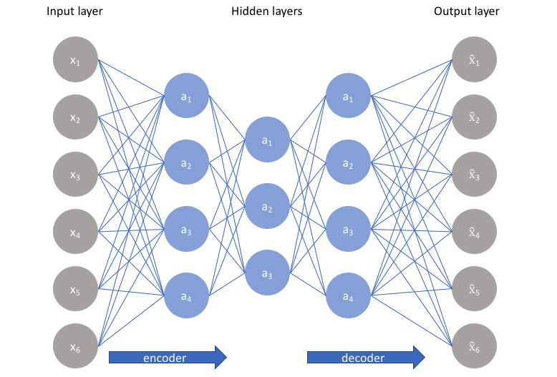

**Figure ‎8.5: Autoencoder Architecture**

### **Definition of Variational Autoencoders**

* Variational Autoencoders (VAEs) are powerful generative models, now having applications as diverse as from generating fake human faces, to producing purely synthetic music.

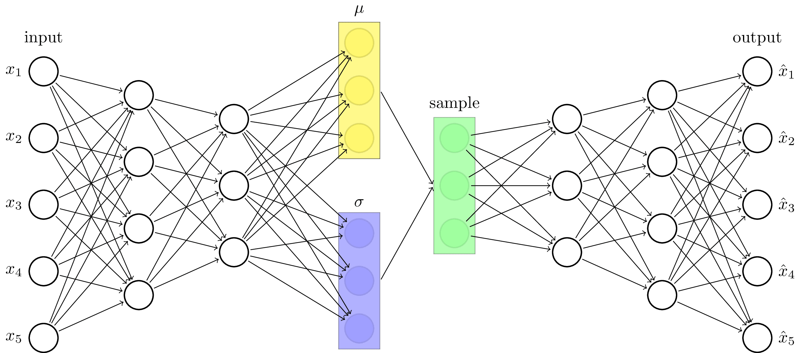

**Figure ‎8.6: Variational Autoencoder Architecture**

* Variational Autoencoders (VAEs) have one fundamentally unique property that separates them from vanilla autoencoders, and it is this property that makes them so useful for generative modeling: their latent spaces are, by design, continuous, allowing easy random sampling and interpolation.
* It achieves this by doing something that seems rather surprising at first: making its encoder not output an encoding vector of size n, rather, outputting two vectors of size n: a vector of means, μ, and another vector of standard deviations, σ.

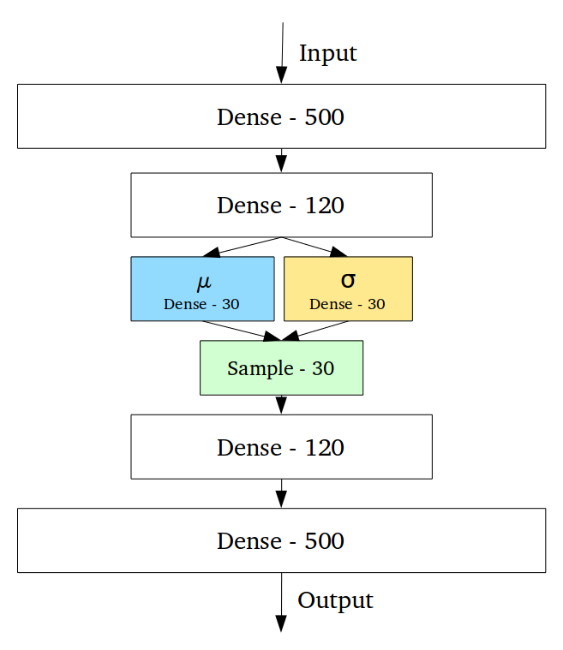

## Flow-based Deep Generative Models

* Neither of GAN, VAE explicitly learns the probability density function of real data, p(x) (where x∈D) because it is hard! Taking the generative model with latent variables as an example, $p(x)=∫p(x|z)p(z)dz$ can hardly be calculated as it is intractable to go through all possible values of the latent code z.
* Flow-based deep generative models conquer this hard problem with the help of normalizing flows, a powerful statistics tool for density estimation. A good estimation of makes it possible to efficiently complete many downstream tasks: sample unobserved but realistic new data points (data generation), predict the rareness of future events (density estimation), infer latent variables, fill in incomplete data samples.
* A flow-based generative model is constructed by a sequence of invertible transformations. The model explicitly learns the data distribution and therefore the loss function is simply the negative log-likelihood.
* Normalizing Flow (NF) model for better and more powerful distribution approximation. A normalizing flow transforms a simple distribution into a complex one by applying a sequence of invertible transformation functions. Flowing through a chain of transformations, we repeatedly substitute the variable for the new one according to the change of variables theorem and eventually obtain a probability distribution of the final target variable.

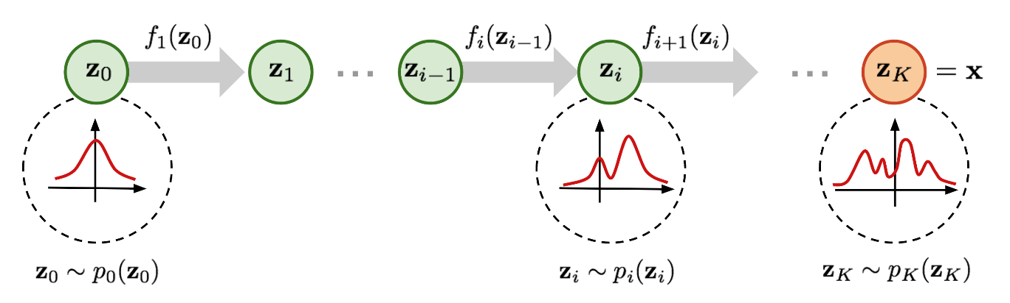

**Figure ‎8.7: Illustration of a normalizing flow model**

## Diffusion Models

* GANs work great for multiple applications however, they are difficult to train, and their output lack diversity due to several challenges such as mode collapse and vanishing gradients. Although VAEs have the most solid theoretical foundation however, the modelling of a good loss function is a challenge in VAEs which makes their output to be suboptimal.
* Diffusion models have emerged as a powerful class of generative learning methods. also known as **denoising diffusion models** or **score-based generative models**.
* Diffusion Models originate from probabilistic likelihood estimation methods and take inspiration from physical phenomenon. The central idea behind Diffusion Models comes from the thermodynamics of gas molecules whereby the molecules diffuse from high density to low density areas. This movement is often referred in physics literature as the increase of entropy or heat death. In information theory, this equates to loss of information due to gradual intervention of noise.
* The key concept in Diffusion Modelling is that if we could build a learning model which can learn the systematic decay of information due to noise, then it should be possible to reverse the process and therefore, recover the information back from the noise. This concept is like VAEs in the way that it tries to optimize an objective function by first projecting the data onto the latent space and then recovering it back to the initial state. However, instead of learning the data distribution, the system aims to model a series of noise distributions in a Markov Chain and “decodes” the data by undoing/denoising the data in a hierarchical fashion.

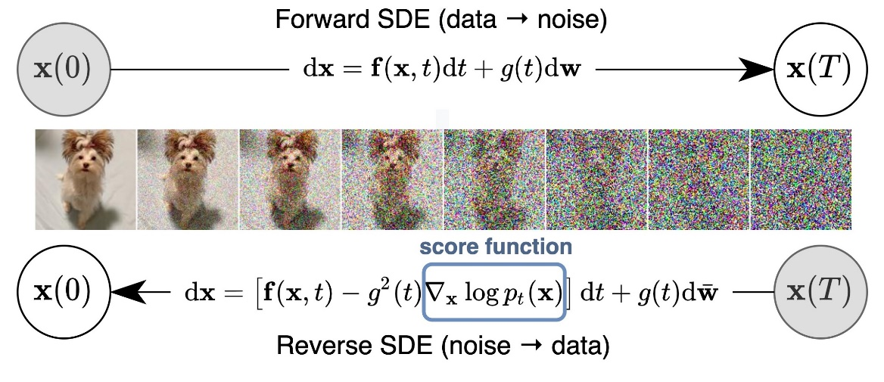

**Figure ‎8.8: Diffusion Model**

Diffusion models consist of two processes: **forward diffusion** and **the reverse/ reconstruction process**.

* **A forward diffusion process** maps data to noise by gradually perturbing the input data. This is formally achieved by a simple stochastic process that starts from a data sample and iteratively generates noisier samples using a simple Gaussian diffusion kernel. At each step of this process, Gaussian noise is incrementally added to the data.
* **The reverse/ reconstruction process** undoes the forward diffusion and performs iterative denoising. This process represents data synthesis and is trained to generate data by converting random noise into realistic data. It is also formally defined as a stochastic process, which iteratively denoises input images using trainable deep neural networks.

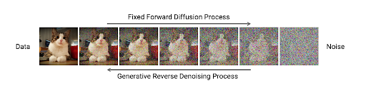

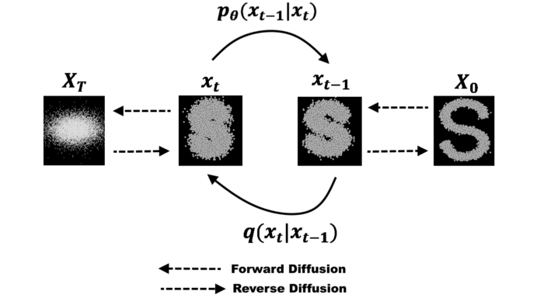

Although Diffusion Models are computationally more expensive than other deep network architectures, however, they perform much better in certain applications. For example, recent applications to text and image synthesis tasks.

### **Forward Process**

We can formally define the forward diffusion process as a Markov Chain and therefore, unlike an encoder in the VAEs it doesn’t require a training. Starting with the initial data point, we add Gaussian noise for T successive steps, and obtain a set of noisy samples. The prediction of probability density at time t is only dependent on the immediate predecessor at time t-1 and therefore, the conditional probability density can be computed as follows:



The complete distribution of the whole process can then be computed as follows:

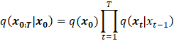

The mean and variance of the density function depends on a parameter βτ, which is a hyper parameter whose value can either be taken as a constant throughout the process or can be gradually changed in the successive steps. For a differential parameter value assignment, there can be range of function that can be used to model the behavior (e.g. sigmoid, tanh, linear etc.).

The above derivation is enough to predict the successive states, however, if we would like to sample at any given time interval t without going through all the intermediary steps, therefore, allowing an efficient implementation, then we can re-formulate the above equation by substituting the hyper-parameter as ατ = 1 — βτ. The reformulation of the above then becomes:



In order to produce samples at a time step t with probability density estimation available at time step t-1, we can employ another concept from thermodynamics called, ‘Langevin dynamics. According to stochastic gradient Langevin dynamics, we can sample the new states of the system only by the gradient of density function in a Markov Chain updates. The sampling of a new data point at time t for a step size ε based on previous point at time t-1 can then be computed as follows:

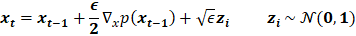

### **Reconstruction**

The reverse process requires the estimation of probability density at an earlier time step given the current state of the system. This means estimating the q(χτ-1 | χτ) when t=T and thereby generating data sample from isotropic Gaussian noise. However, unlike the forward process, the estimation of previous state from the current state requires the knowledge of all the previous gradients which we can’t obtain without having a learning model that can predict such estimates. Therefore, we shall have to train a neural network model that estimates the ρθ(χτ-1|χτ) based on learned weights θ and the current state at time t. This can be estimated as follows:



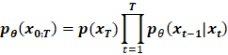

The parameterization for mean function can be computed as follows:

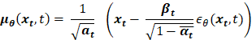

### **Training and Results**

#### **Construction of The Model**

The model used in the training for diffusion model follows the **similar patterns to a VAE network** however, it is often kept much simpler and straight-forward compared to other network architectures. **The input layer** has the same input size as that of the data dimensions. There can be multiple hidden layers depending on the depth of the network requirements. **The middle layers** are linear layers with respective activation functions. **The final layer** is again of the same size as that of the original input layer, thereby reconstructing the original data. In the Denoising Diffusion Networks the final layer consists of two separate outputs, each dedicated to the mean and variance of the predicted probability density respectively.

* + - 1. **Computation of Loss Function**

The objective of the network model is to optimize the following loss function:

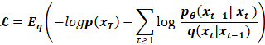

The loss function formulates the loss in terms of a linear combination of KL-divergence between two gaussian distributions and a set of entropies. This simplifies the computation and makes it easy to implement the loss function. The loss function then becomes:



A further simplification and improvement in the loss function whereby the parameterization for the mean is used as described in the previous section for the forward process. Therefore, the loss function then becomes:



* + - 1. **Results**

The results for the forward process which adds Gaussian noise by following a Markov Chain can be seen in the following figure. The total number of time steps were 100 while this figure shows 10 samples from the generated set of sequences.

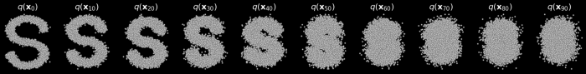

**Figure ‎8.9: Results of a forward Diffusion process**

* The results for the reverse diffusion process can be seen in the following figure. The quality of the final output depends on the tuning of the hyper-parameters and number of training epochs.

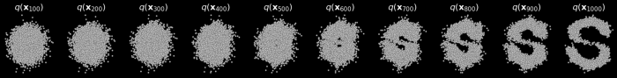

**Figure ‎8.10: Results of reconstruction of data**

# **Our model**

* **Based on** CLIP + VQGAN **from** Taming Transformers.
* **various** CLIP models (incl. multi-language from SBERT).

# **VQ-GAN**

## What is VQGAN?

* **VQGAN** is a type of neural network architecture.
* **VQGAN** stands for Vector Quantized Generative Adversarial Network.
* **It** was first proposed in the paper “Taming Transformers” by University Heidelberg (2020).
* It combines convolutional neural networks (traditionally used for images) with Transformers (traditionally used for language).
* It’s great for high-resolution images.
* VQGAN is that it prescribes an explanation of how we see things.

## VQGAN Architecture

* VQGAN can learn not only the visual parts of an image but also their relationships.  Convolutional neural networks (CNN) proved that we can model local interactions between pixels by restricting interactions within their local neighborhood (i.e., the [*kernel*](https://en.wikipedia.org/wiki/Kernel_(image_processing))).
* This allows us to “compose” pixels together and learn visual parts, The premier illustration for this is the feature map below, where a CNN learned how to compose pixels at varying layers of abstraction: pixels become edges, edges become shapes, and shapes become parts.
* Putting it all together, we now have two complementary techniques:

1. An interesting view of perception that allows us to **model long-range dependencies** by representing images discretely.
2. A pixel-based approach to learning **local interactions** and **visual parts**.

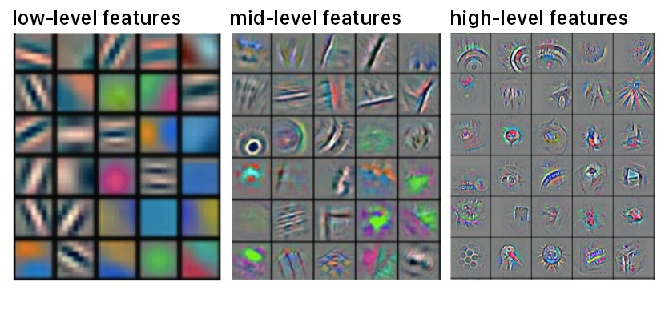

**Figure ‎9.1: A convolutional neural network feature map showing features at different levels.**

**VQGAN was able to combine both.** It can learn not only the visual parts of an image but also the relationship (read: long-range dependencies) between these parts.

The table below summarizes the two:

| **Approach** | **Examples** | **Can model** | **Analogy** |
| --- | --- | --- | --- |
| **Discrete** | The sequence of symbols, words, phrases, and sentences | Long-range dependencies | Perceiving |
| **Continuous** | RGB channels in a pixel, convolutional filters, etc. | Local interactions and visual parts | Sensing |

## Using Transformers to model interactions

* A continuous approach that learns visual parts using a convolutional neural network and a discrete approach that learns long-range dependencies across them. VQGAN was able to take advantage of the two approaches.

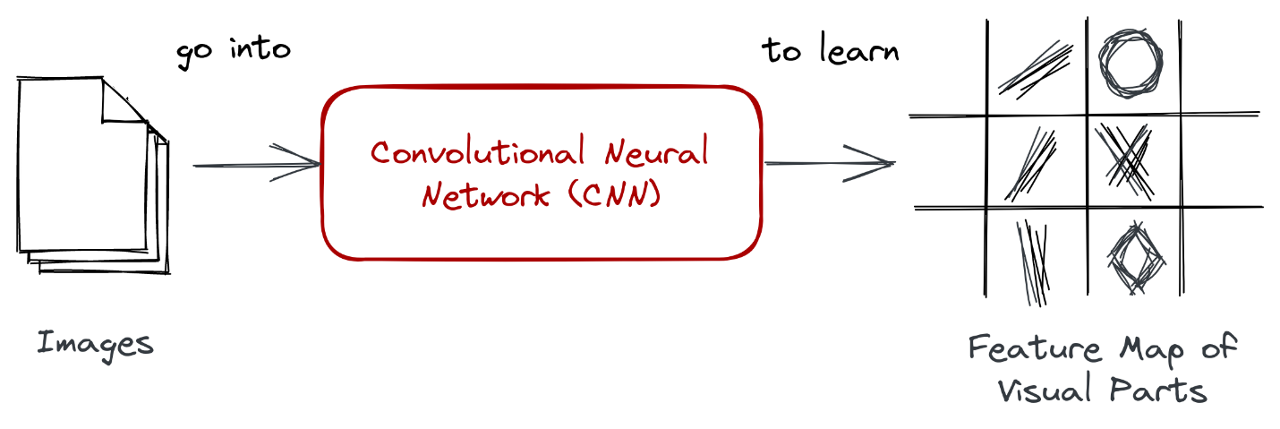

**Figure ‎9.2: A CNN can learn high-level features that we refer to as visual parts.**

* The model did not synthesize the image from a pixel level directly, but instead from the codewords of the learned codebook.
* VQGAN uses a **codebook** to represent visual parts.

## Expressing images through a codebook

* **The codebook is generated through a process called vector quantization (VQ)**, i.e., the “VQ” part of “VQGAN.” Vector quantization is a signal processing technique for encoding vectors. It represents all visual parts found in the convolutional step in a quantized form, making it less computationally expensive once passed to a transformer network.
* vector quantization is a **process of dividing vectors into groups that have approximately the same number of points closest to them**. Each group is then represented by a centroid (codeword), usually obtained via [k-means](https://en.wikipedia.org/wiki/K-means_clustering) or any other [clustering algorithm](https://en.wikipedia.org/wiki/Cluster_analysis).
* In the end, one learns a dictionary of centroids (codebook) and their corresponding members.

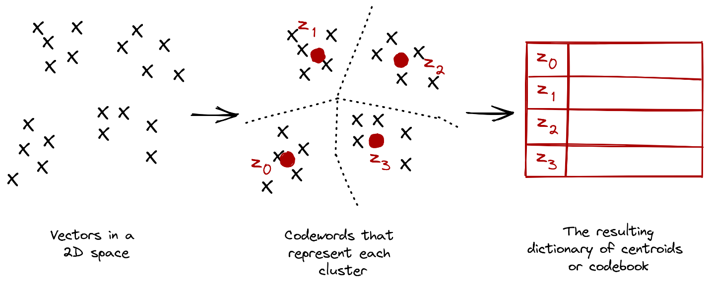

**Figure ‎9.3: Vector quantization finds the representative centroids for each cluster.**

## Putting it all together

At this point, all the ingredients needed to discuss VQGAN’s architecture is prepared:

* A **convolutional neural network that takes a set of images to learn their visual parts.** By taking advantage of a pixel’s local interactions, high-level features to construct new imagery can be learned.
* A **transformer network that takes a sequence to learn their long-range interactions.** Given a discrete representation, a transformer allows us to understand relationships across visual parts.
* A **codebook was obtained via vector quantization.** It consists of discrete codewords that allow us to easily train a transformer on top of it.

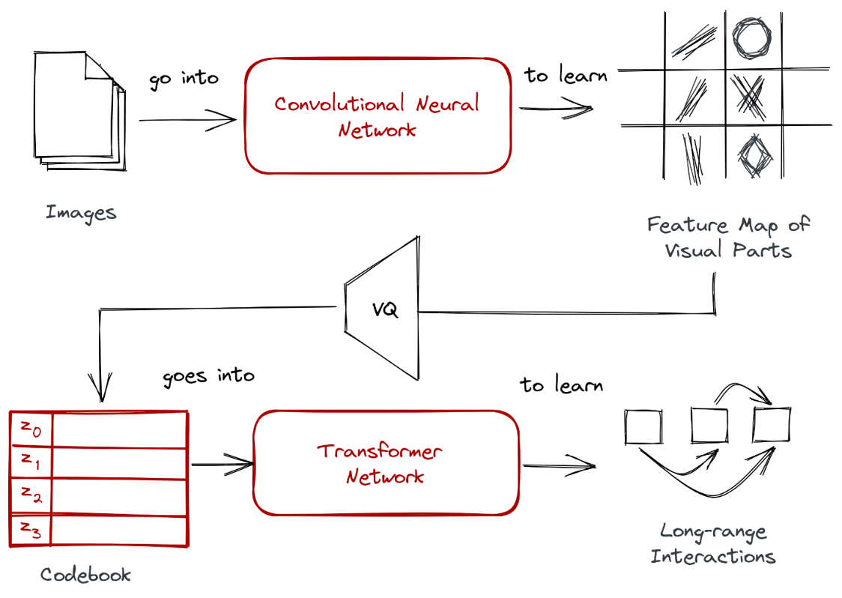

**Figure ‎9.4: Quantization of output of CNN + Transformer network.**

However, there is make a few tiny adjustments:

* **the simple convolutional neural network is replaced with a generative adversarial network.** The layers still perform a convolution operation, but with a GAN it synthesizes more distinct visual parts.
* **Instead of having a separate process for vector quantization, VQGAN will learn the codebook right away.** Learning the feature map of visual parts happens inside the GAN. It’s still the same two-stage approach.

Below is the **complete architecture diagram** for VQGAN:

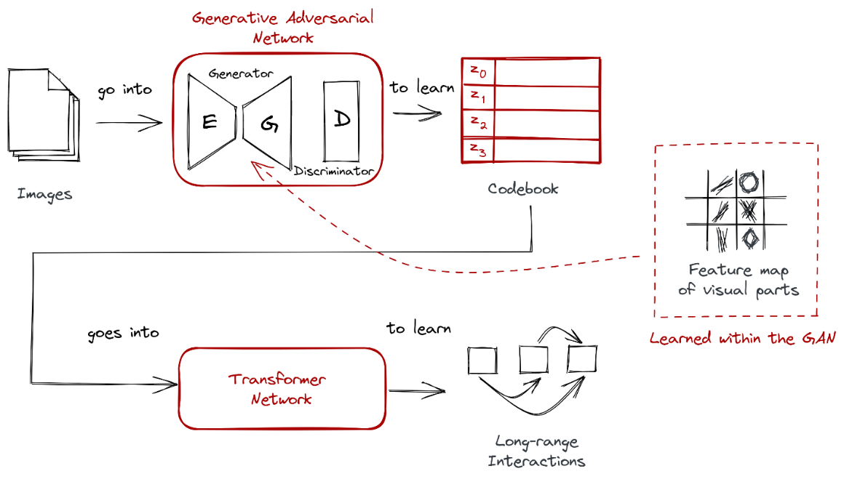

**Figure ‎9.5: Instead of CNN we use GAN**

* Although VQGAN involves Transformers the models are not trained with text, but pure image data.
* They just apply the Transformer architecture that was previously used for text to images, which is an important innovation.

# **Transformers**

## Introduction to Taming transformer

* At first, convolutional neural network (CNN) transmission models were used for vision tasks, then they are not used because they show strong local bias and bias towards spatial stability using common weights and cannot represent large distances.
* then the transformer comes to solve this problem because it does not have an inductive bias that prioritizes local interactions and allows them to learn the complex relationships between Input, as previous work that applied transformers to image generation showed promising results for images up to 64 × 64 pixels in size but could not be scaled to higher resolution due to cost increasing quadratic with sequence length. To use transformers to assemble high-resolution images, we need to intelligently represent the semantics of the image. Using pixel representation will not work because the number of pixels increases squared as the image resolution increases by 2x.
* so, the transformer is not the final model because of these problems where the transformer is computationally expensive, so they are used taming transformer in the final, that it solves the problems of the transformer, it does not represent the image by pixel, but it used a learned codebook to represent visual parts.

***We will use the Taming transformer in this project, so what is Taming transformer?***

* **Taming transformers** are a type of vision transformer in which, unlike convolutional neural networks (CNNs), in general, the architecture of vision transformer does not have a prefabricated inductance in the interaction region and is, therefore, free to learn the complex correlations between its inputs.
* However, due to this generality, all relevant vessels must learn, while CNNs aim to benefit from prior knowledge of strong local correlations within images. Since all pairwise interactions are considered, a higher expression for transformers comes with a higher processing costs square. As a result, the latest model’s convertible to high-resolution images is difficult to scale due to power and time requirements, so we divide the image into grids rather than using them in pixel terms.

## Methodology of the transformers

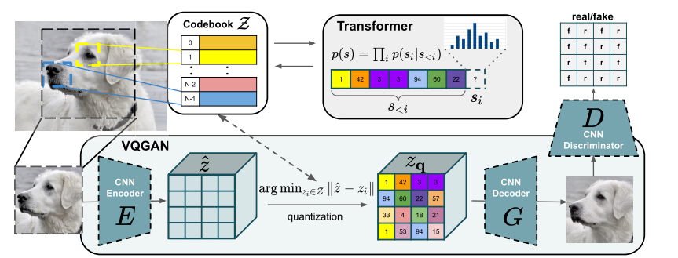

**Figure ‎10.1: This approach learns a codebook of context-rich visual parts.**

### **Training of GAN**

* To utilize the highly expressive transformer architecture for image synthesis, we need to express the constituents of an image in the form of a sequence. Instead of building on individual pixels, complexity necessitates an approach that uses a discrete codebook of learned representations, such that any image $x∈ R^{H×W×3}$ can be represented by a spatial collection of codebook entries $Zq∈ R^{h×w×n_{z}}$, where nz is the dimensionality of codes.
* An equivalent representation is a sequence of h · w indices that specify the respective entries in the learned codebook. To effectively learn such a discrete spatial codebook, we propose to directly incorporate the inductive biases of CNNs and incorporate ideas from neural discrete representation learning.

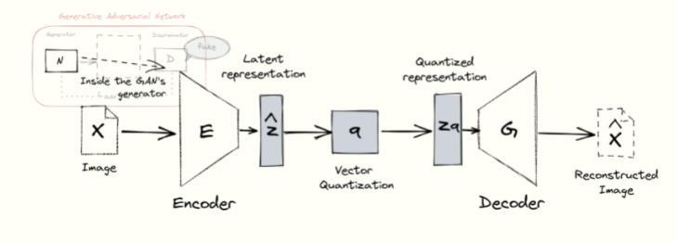

**Figure ‎10.2: The GAN’s generator contains an autoencoder network.**

* First, we learn a convolutional model consisting of an encoder E and a decoder G, such that taken together, they learn to represent images with codes from a learned, discrete codebook.
$$Z = {\left\{z_{k}\right\}}_{k=1}^{k} ⊂ R^{n_{z}}$$

* This approach approximates a given image x by $\hat{x}$ = G ($z_{q}$). We obtain $z_{q}$ using the encoding

$\hat{z}$ = E(x) ∈ $R^{h×w×n_{z}}$ and a subsequent element-wise quantization q (·) of each spatial code

${\hat{z}}_{ij}$ ∈ $R^{n_{z}}$ onto its closest codebook entry

$z_{k}: z_{q}=q\left(\hat{z}\right):={argmin}_{z_{k}∈Z}\left\|{\hat{z}}_{ij}- z_{k}\right\|∈R^{h×w×n_{z}}$,

* The reconstruction $\hat{x}≈x$ is then given by $\hat{x}$ = G ($z_{q}$) = G (q(E(x))). (3)
* Backpropagation through the non-differentiable quantization operation in Eq. (3) is achieved by a straight-through gradient estimator, which simply copies the gradients from the decoder to the encoder [3], such that the model and codebook can be trained end-to-end via the loss function

LVQ (E, G, Z) = $\left\|x-\hat{x}\right\|+{\left\|sgE\left(x\right)-z_{q}\right\|}_{2}^{2}+{\left\|sg\left(z_{q}\right)-E\left(x\right)\right\|}_{2}^{2}$.

* Here, L-rec = $\left\|x-\hat{x}\right\|$ is a reconstruction loss, sg [·] denotes the stop-gradient operation, and ${\left\|sg\left(z_{q}\right)-E\left(x\right)\right\|}_{2}^{2}$ is the so-called “commitment loss”.
* This approach replaces the L2 loss for L-rec by a perceptual loss and introduces an adversarial training procedure with a patch-based discriminator D that aims to differentiate between real and reconstructed images:
$$L_{GAN}\left(\left\{E,G,Z\right\},D\right)=[\log{D\left(x\right)}+\log\left(1-D\left(\hat{x}\right)\right)]$$

* The complete objective for finding the optimal compression model $Q^{*}$ = {$E^{*},G^{*},Z^{*}\}$ then reads

$$Q^{*}={argmin}_{E,G,Z }\max_{D }E_{x≈p(x)}[l_{VQ}\left(E,G,Z\right)+λl_{GAN\left(\left\{E,G,Z\right\},D\right)}]$$

where we compute the adaptive weight λ according to

$$λ=\frac{∇_{GL}\left[L_{rec}\right]}{∇_{GL}\left[L_{GAN}\right]+δ}$$

where L-rec is the perceptual reconstruction loss, $∇_{GL}$ [·] denotes the gradient of its input w.r.t. the last layer L of the decoder, and δ = 10−6

* **When put together, we obtain the discrete capabilities of VQ, the rich expressivity of GANs, and the encoding capabilities of the autoencoder.**

### **Training the transformer**

* We’re only interested in the codebook ZZ because it provides a discrete representation of our visual parts that can readily be fed to a transformer. To do so, **we represent the images in terms of the codebook indices of their embeddings.**
* This means that the encoding zq of an image xx can be represented as a sequence ss from our codebook Z, that is s∈ {0, …,|Z|−1}.

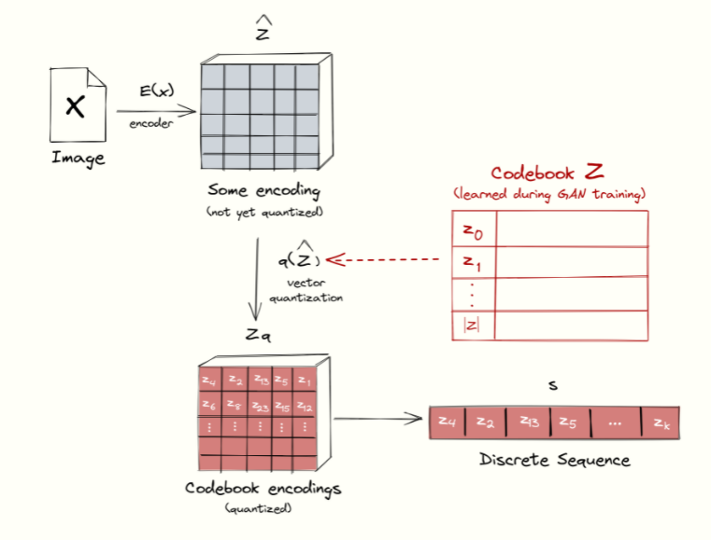

**Figure ‎10.3: Representing images in a sequence corresponding to the codebook indices of their embeddings.**

## Transformer loss

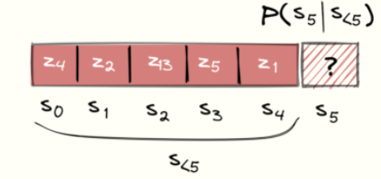

**Figure ‎10.4: Training the transformer is done via next-word prediction like languages.**

* Given indices $S_{<i}$, the transformer learns to predict the distribution of possible next indices $p(S_{i}|S_{<i})$ to compute the likelihood of the full representation as $p\left(s\right)=Π_{i}p(S_{i}|S_{<i})$ This allows us to directly maximize the log-likelihood of the data representations:

$$L_{transformer}E_{x≈p(x)}[-\log{p\left(s\right)]}$$

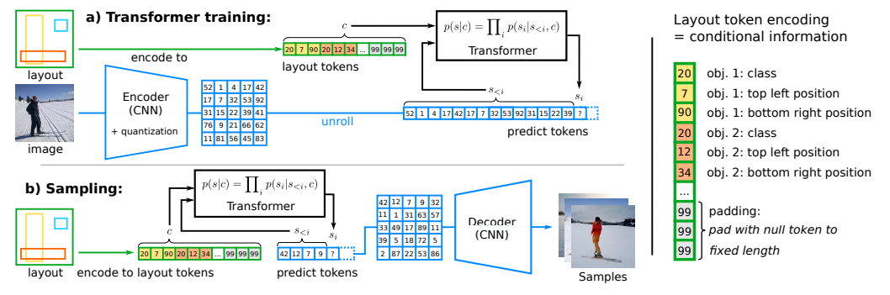

**Figure ‎10.5: Encoder and decoder are trained in the first stage as a VQGAN.**

* In many images synthesis tasks, a user demands control over the generation process by providing additional information. This information, which we will call c, could be a single label describing the overall image class or even another image itself. The task is then to learn the likelihood of the sequence given this information c $p\left(s|c\right)=Π_{i}p(S_{i}|S_{<i},c)$

## Generating High-Resolution Images:

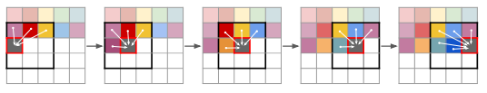

**Figure ‎10.6: When sampling images, VQGAN used sliding attention to different patches.**

* The attention mechanism of the transformer puts limits on the sequence length h · w of its inputs s. While we can adapt the number of down sampling blocks m of our VQGAN to reduce images of size

H × W to h = H/2 m × w = W/2 m.

* Lastly, for sampling the images, we use the transducer by sliding window method to restrict the context via a sliding window. This means that when generating each patch, it obtains information only from its neighbors. It’s a nice “trick” to improve resource efficiency when using transformers.

# **Clip (Contrastive Language Image Pre-training)**

## Transfer Learning

* Transfer learning (TL) is a technique in machine learning (ML) that focuses on storing knowledge gained while solving one problem and applying it to a different but related problem. For example, knowledge gained while learning to recognize cars could apply when trying to recognize trucks.
* From the practical standpoint, reusing or transferring information from previously learned tasks for the learning of new tasks has the potential to significantly improve the sample efficiency of a reinforcement learning agent.
* Transfer learning is an optimization, a shortcut to saving time or getting better performance.

## Zero-shot Learning

* Zero-Shot Learning (ZSL) is a Machine Learning paradigm where a pre-trained deep learning model is made to generalize on a novel category of samples, i.e., the training and testing set classes are disjoint.
* For example, a model trained to distinguish between images of cats and dogs is made to identify images of birds. The classes covered by the training instances are referred to as the “seen” classes, while the unlabeled training instances are referred to as the “unseen” classes.

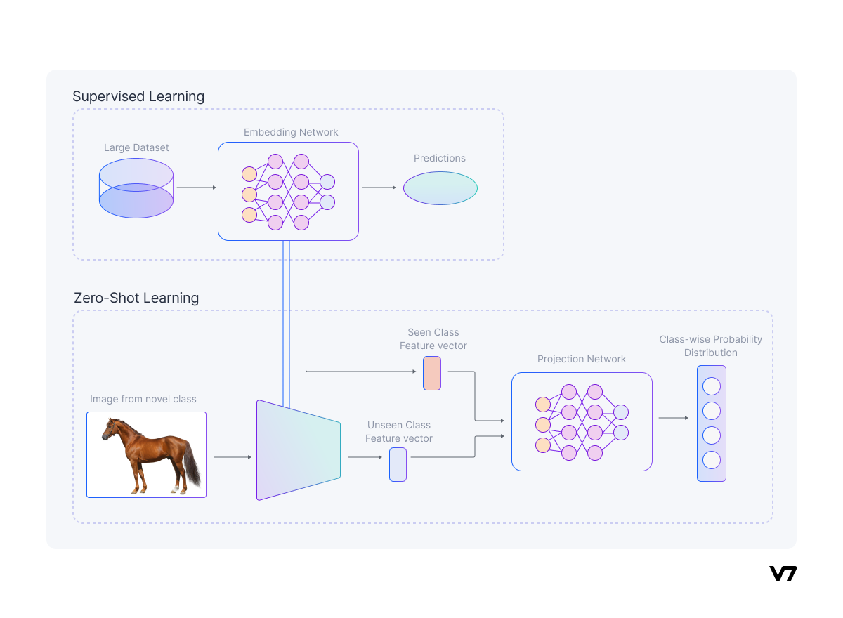

**Figure ‎11.1: Zero-Shot Learning Process**

* The general idea of zero-shot learning is to transfer the knowledge already contained in the training instances to the task of testing instance classification. Thus, zero-shot learning is a subfield of transfer learning.
* The most common form of Transfer Learning involves fine-tuning a pre-trained model a problem with the same feature and label spaces. This is called “homogenous transfer learning.”
* Zero-Shot Learning belongs to “heterogeneous transfer learning”, where the feature and label spaces are disparate.
* Zero-Shot Learning relies on a labeled training set of seen and unseen classes. Both seen and unseen classes are related in a high dimensional vector space, called semantic space, where the knowledge from seen classes can be transferred to unseen classes.

### **The importance of Zero-Shot Learning:**

* Data labeling is a labor-intensive job.
* You also might be lacking enough training data for each class captured in the conditions that would help the model reflect the real-world scenarios.
* For example, if a new bird species has just been identified, an existing bird classifier needs to generalize on this new species. Perhaps the new species identified is rare and has only a few instances, while the other bird species have thousands of images per class. As a result, your dataset distribution will be imbalanced and, therefore, hindering model performance even in a fully supervised setting.
* Methods like unsupervised learning also fail in scenarios where different sub-categories of the same object need to be classified for instance, trying to identify different breeds of dogs.
* Zero-Shot Learning aims to alleviate such problems by performing image classification on the fly on novel data classes (unseen classes) by using the knowledge already learned by the model during its training stage.

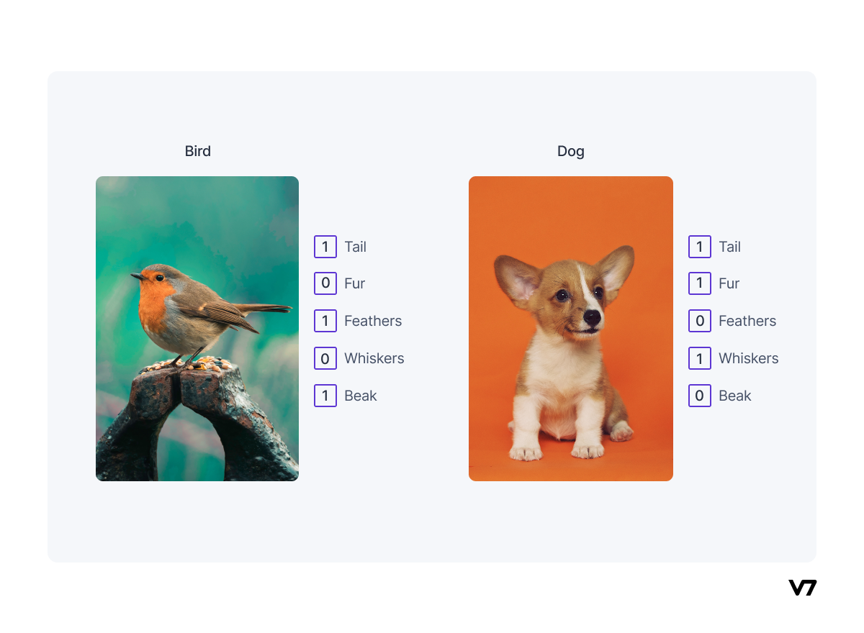

**Figure ‎11.2: Example of semantic embedding using an attribute vector.**

## Introduction To CLIP Model

* The development of “text-to-text” as a standardized input-output interface has enabled task-agnostic architectures to zero-shot transfer to downstream datasets removing the need for specialized output heads or dataset specific customization.
* Flagship systems like GPT-3 are now competitive across many tasks with bespoke models while requiring little to no dataset specific training data.
* They create a new dataset of 400 million (image, text) pairs and demonstrate that a simplified version of ConVIRT trained from scratch, which They call CLIP, for Contrastive Language-Image Pre-training, is an efficient method of learning from natural language supervision.
* **CLIP** is the first **multimodal** *(in this case, vision, and text)* model tackling computer vision and was recently released by OpenAI on January 5, 2021.
* "It can predict the most relevant text snippet, given an image." You can input an image into the CLIP model, and it will return for you the likeliest caption or summary of that image.
* **CLIP is a bridge between computer vision and natural language processing.**
  + computer vision is "the ability for a computer to see and understand what it sees like humans."
  + NLP in a similar way: "the ability for a computer to understand language like humans."
  + It's not just a bridge between computer vision and natural language processing -- it's a very powerful bridge between the two that has a lot of flexibility and a lot of applications.
* They constructed a new dataset of 400 million (image, text) pairs collected form a variety of publicly available sources on the Internet. To attempt to cover as broad a set of visual concepts as possible, we search for (image, text) pairs as part of the construction process whose text includes one of a set of 500,000 queries (words occurring at least 100 times in the English version of Wikipedia) and take up to 20k images per query. The resulting dataset has a similar total word count as the WebText dataset used to train GPT-2.
* Given a batch of N (image, text) pairs, CLIP is trained to predict which of the N × N possible (image, text) pairings across a batch occurred. To do this, CLIP learns a multi-modal embedding space by jointly training an image encoder and text encoder to maximize the cosine similarity of the image and text embeddings of the N real pairs in the batch while minimizing the cosine similarity of the embeddings of the N2 − N incorrect pairings.
* Before CLIP was released, image classification was struggling with either insufficient data to feed ML models or the cumbersome process of labelling data. Despite vast annotated datasets like ImageNet, which comprise 14 million labelled images, models failed to perform well if the datasets were even slightly tweaked. Even such vast datasets proved to be small for training models on generalizability. There were two ways to tackle this problem: either the models themselves could be improved, or the datasets could be made more diverse. CLIP attempted to revolutionize image classification via the second approach.
* When tested by OpenAI, the study showed that CLIP was four times more efficient at zero-shot ImageNet accuracy when compared to other methods.
* The image classifier was used to evaluate the efficacy of the image generator. In fact, CLIP has been behind the success of several tools in the growing AI-generated art scene. CLIP helps GANs or Generative Adversarial Networks to move in the right direction.
* Released in 2021, a generative model called CLIP+VQGAN or Vector Quantized Generative Adversarial Network is used within the text-to-image paradigm to generate images of variable sizes, given a set of text prompts. However, unlike VQGAN, CLIP isn’t a generative model and is simply trained to represent both images and text effectively.
* CLIP’s ability to work with unseen datasets sometimes makes it much better than models that have been trained on specific datasets. The lesser data CLIP is trained on, the better it performs. According to a study, CLIP outperformed custom trained ResNet classification models in a task which involved classifying flowers.

## How CLIP Works?

* **The CLIP model consists of two sub-models called encoders:**
  + a text encoder that will embed text into mathematical space.
  + an image encoder that will embed images into mathematical space.
* **Two versions for image encoder:**
* ResNet-50 with a few modifications.
* Vision transformer (ViT).
* The text encoder and image encoder are fit to maximize goodness and minimize badness.
* In the image below, you'll see a set of purple text cards going into the text encoder. The output for each card would be a series of numbers.
* The exact same thing will happen for the images: each image will go into the image encoder and the output for each image will also be a series of numbers.

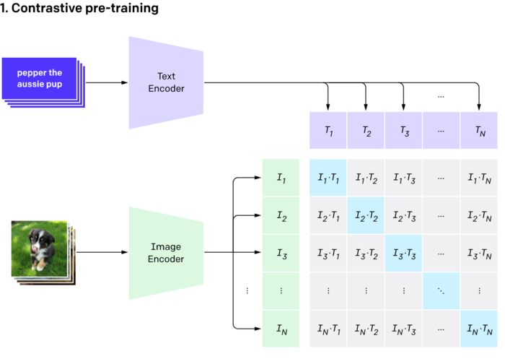

**Figure ‎11.3: The pre-training phase.**

* In an ideal world, the series of numbers for the text "pepper the assize pup" will be very close (identical) to the series of numbers for the corresponding image. In fact, this should be the case everywhere: the series of numbers for the text should be very close to the series of numbers for the corresponding image. One way for us to measure "goodness" of our model is how close the embedded representation (series of numbers) for each text is to the embedded representation for each image.
* There is a convenient way to calculate the similarity between two series of numbers: the cosine similarity.
* In the image above, the light blue squares represent where the text and image coincide. For example, T1 is the embedded representation of the first text; I1 is the embedded representation of the first image. We want the cosine similarity for I1 and T1 to be as high as possible. We want the same for I2 and T2, and so on for all the light blue squares. The higher these cosine similarities are, the more "goodness" our model has.
* At the same time as wanting to maximize the cosine similarity for each of those blue squares, there are a lot of grey squares that indicate where the text and image don't align.
* we want all the grey squares to have low cosine similarities, because that measures "badness."
* The text encoder and image encoder get fit at the same time by simultaneously maximizing the cosine similarity of those blue squares and minimizing the cosine similarity of the grey squares, across all our (text, image) pairs.

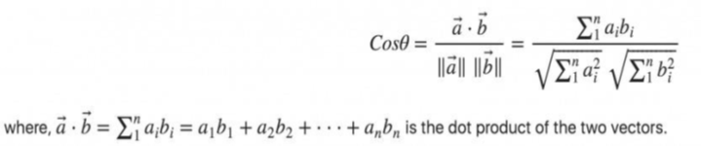

**Figure ‎11.4: Cosine Similarity Formula.**

* Once the model is fit, you can pass an image into the image encoder to retrieve the text description that best fits the image – or, vice versa, you can pass a text description into the model to retrieve an image.

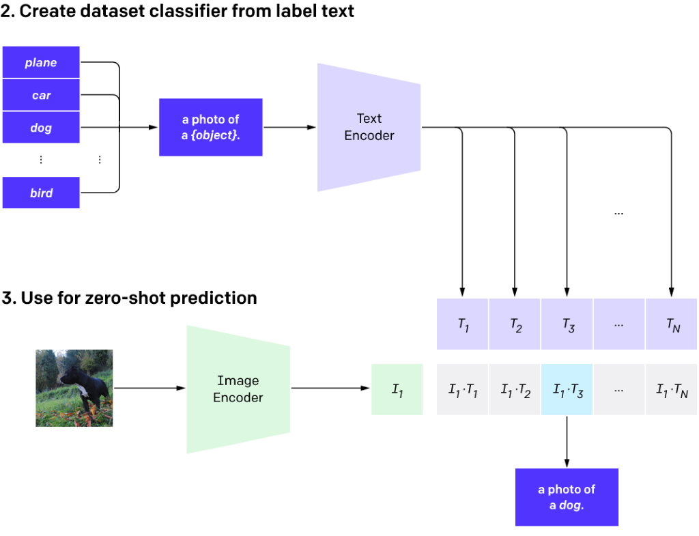

**Figure ‎11.5: CLIP as Classifier after Training.**

* CLIP targets the Natural Language for Visual Reasoning (NLVR) problem as it tries to classify an image to a specific label based on its context. The label is usually a phrase or a sentence describing the image. More interestingly, it’s a zero-shot classifier in terms that it can be used to previously unseen labels.
* The model tries to discover which text vector is more “appropriate” for a given image vector. Therefore, it’s referred to as contrastive learning.
* **There are different ways of representing text for prediction as shown in the figure below:**

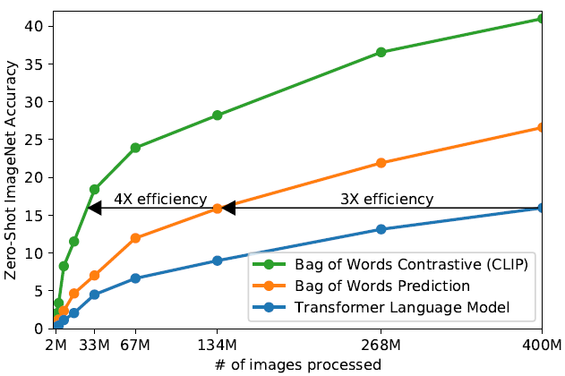

**Figure ‎11.6: CLIP is much more efficient at zero-shot transfer.**

* One can predict text with the correct word order, i.e., the classifier must output this is a photo of a cat. Or one can predict a label based on a bag of words, i.e., the order of words is not important and if the classifier predicts photo, cat, then it is correct.
* OpenAI suggests a further improvement upon the bag of words method and shows that CLIP is 4x more efficient in zero-shot ImageNet accuracy compared to previous methods.
* CLIP achieves this by reframing the problem and using contrastive pre-training. Instead of predicting label text, CLIP is training on predicting how likely this image is to correspond to that text.

## Clip Approach

### **Contrastive pre-training**

* Contrastive pre-training involves training an image encoder and a text encoder in the multi-modal embedding space to predict the correct pairings of a batch of (image, text) training examples.

### **The image encoder**

* Image augmentation is first performed on the images before being passed into the image encoder module.
* Two different architectures are used for the image encoder: the ResNet-50 and the Vision Transformer (ViT). The ResNet-50 model was one of the earliest convolutional neural networks and has 50 layers in depth. Because of its deep framework, it is popularly used to train ultra-deep neural networks.
* In the first architecture, the ResNet-50 model is used as the base image encoder architecture.
* The global average pooling layer present in the ResNet-50 was replaced with an attention pooling mechanism popularly used in NLP to compose representations.
* In the second architecture, they used the Vision Transformer (ViT) recently introduced by Google. The only modification performed on this architecture is the addition of the layer normalization just before the transformer module.
* This layer is added to the combined patch and position embeddings layers. The outputs from the image decoder are fed into the multi-modal embedding space.

### **The text encoder**

* The text encoder is a Transformer with 12-layers, a 512-wide model with eight attention heads, and it is used as the base architecture for the text encoder. The text encoder uses the start-of-sequence (SOS) and end-of-sequence (EOS) token signals used in NLP as feature representations of the text inputs. These representations are layer normalized and linearly projected into the multi-modal embedding space.
* In this module, it is essential to note that they only scale the model’s width so that it can be proportional to the calculated increase in width of the ResNet-50 architecture in the image decoder. This is essential as both the image encoder and the text encoder are to be jointly trained in the multi-modal embedding space. Only the width is scaled; its depth is not scaled at all.

### **The multi-modal embedding space**

* In the multi-modal embedding space, the image encoder and text encoder are jointly trained to maximize the cosine similarity of the image and text embeddings of the real pairs in the batch. On the flip side, the cosine similarity of the embeddings with incorrect pairings was also minimized.
* For example, in a batch size of N (image, text) pairs, the model predicts which of the N X N possible (image, text) pairings across a batch are similar and incorrect pairs. This means that real pairs have a cosine similarity value closer to 1, while incorrect pairs had a value closer to 0.

### **Create dataset classifier from label text**

* Here, they perform the pattern exploiting training which involves leveraging pre-trained language models to label data for downstream tasks. They embed object classes into captions such as “a photo of an {object}” or “a centered satellite photo of {object}.”
* For example, “a photo of a dog” or “a centered satellite photo of pastureland.” They encode these captions into the text encoder configured with pre-trained weights from the multi-modal embedding space training. This process produces batches of text embeddings.
* This process allows for zero-shot classification.

### **Use for zero-shot prediction**

* Zero-shot learning is a new research area that predicts objects during test time whose classes were not seen during training. In the CLIP model, zero-shot learning is used in a broader sense to generalize any unseen datasets.
* This prediction is accomplished by taking the input image that we want to classify and pass through the image encoder. This produces its embedding vector. They then performed the cosine similarity between the image’s embedding vector and the textual embedding vectors. The value with the highest cosine similarity (closer to 1) is the predicted class.
* For example, if the input image were the photo of a horse, the output with the highest similarity would be “a photo of a horse.”
* One detail that is worth mentioning is that CLIP is sensitive to words used for image descriptions. Texts “a photo of a bird”, “a photo of a bird sitting near bird feeder”, or “an image of a bird” all produce different probabilities paired with the same image:

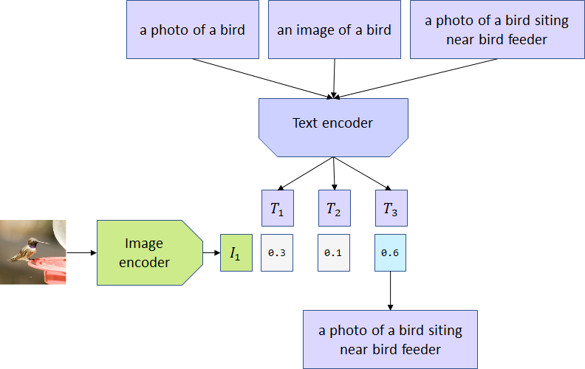

**Figure ‎11.7: Zero-shot prediction.**

### **Result**

* It is evident that these classifiers perform well on a wide range of tasks, but not all the time. For example, it correctly classified the guacamole, television studio, and airplane result while misclassifying the annual cropland as permanent cropland.
* We can also distinctly note that these results are all from a diverse set of tasks and different datasets, i.e., Food101, Sun397, YouTube-BB, and Eurostat datasets.
* Interestingly, it is also important to note that the labels are not the typical type of labels that we would see in a classifier. For example, the model classifies the label guacamole correctly and attaches the tag “a photo of guacamole, a type of food.” This is new.
* The model performs these tasks purely through “zero-shot learning,” which means that the model had not seen these images of different datasets before being tested on them. It’s not trained on these tasks but seems to perform well enough.

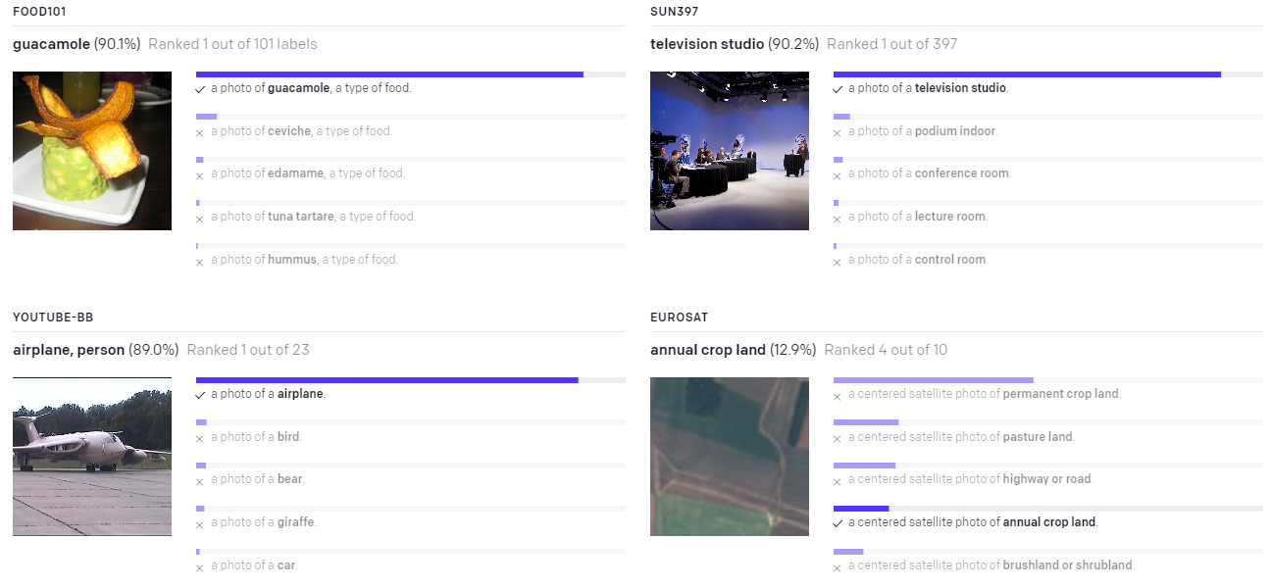

**Figure ‎11.8: Predictions of zero-shot CLIP classifiers on examples from various datasets.**

## Advantages of CLIP

* **Generalizability**: Models are usually super brittle, capable of knowing only the very specific thing you trained them to do. CLIP expands knowledge of classification models to a wider array of things by leveraging semantic information in a text. Standard classification models completely discard the semantic meaning of the class labels and simply enumerate numeric classes behind the scenes; CLIP works by understanding the meaning of the classes.
* **Connecting text/images better than ever before**: CLIP may quite literally be the "world's best caption writer" when considering speed and accuracy together.
* **Already-labeled data**: CLIP is built on images and captions that were already created; other state-of-the-art computer vision algorithms required significant additional human time spent labeling
* **Good performance with (classification, image feature utilization):** CLIP training pushes the boundaries of traditional classifiers a bit further, and the released pre-trained model allows one to perform various computer vision tasks (classification, image feature utilization) with good performance and without a need for a training set. As one of the pain points when working on real projects in data science is data scarcity, where there may be a lack of ground truth data, or the amount of data is limited. As I show with an example, a pre-trained CLIP-based model allows to kick-start such projects – thus this development is a welcomed addition to the Data Science toolbox.
* **Act as a classifier**: When this model has trained on a huge dataset of images and their corresponding texts, it can also act as a classifier too. CLIP model trained with this strategy classifies ImageNet better than those SOTA models trained on the ImageNet itself optimized for the only task of classification!

## CLIP Problems

* The CLIP model itself is data-hungry and expensive to train.
* The ability to adapt to new datasets and classes is related to the text encoder. It is thus limited to choosing from only those concepts known to the encoder. CLIP model trained with English texts will be of little help if used with texts in other languages.

Note: this can take a very long time depending on the size of your data. The CLIP model trained on 400,000,000 labeled images. The training process took 30 days across 592 V100 GPUs. This would have cost $1,000,000 to train on AWS on-demand instances!

## Use Cases of CLIP

One of the neatest aspects of CLIP is how versatile it is. When introduced by OpenAI they noted two use-cases: image classification and image generation. But in the 9 months since its release, it has been used for a far wider variety of tasks.

### **Image classification**

* OpenAI originally evaluated CLIP as a zero-shot image classifier. They compared it against traditional supervised machine learning models, and it performed nearly on par with them without having to be trained on any specific dataset.
* One challenge with traditional approaches to image classification is that you need lots of training examples that closely resemble the distribution of the images it will see in the wild. Because of this, CLIP does better on this task the less training data there is available.

### **Image Generation**

* DALL-E was developed by OpenAI in tandem with CLIP. It's a generative model that can produce images based on a textual description; CLIP was used to evaluate its efficacy.
* CLIP has been behind a burgeoning AI generated art scene. It is used to "steer" a GAN (generative adversarial network) towards a desired output. The most used model is Taming Transformers' CLIP+VQGAN which we dove deep on here.

### **Image Search**

* + Because CLIP doesn't need to be trained on specific phrases, it's perfectly suited for searching large catalogs of images. It doesn't need images to be tagged and can-do natural language search.
  + Yurij Mikhalevich has already created an AI-powered command image line search tool called rclip.

### **Robotics Control**

* The CLIPort model combines CLIP with another model to allow robots to perform abstract tasks like folding laundry or sorting cubes without having to be given explicit instructions for how to accomplish the objective.

### **Image Captioning**

* With the CLIP prefix captioning repo, the feature vectors from CLIP have been wired into GPT-2 to output an English description for a given image.

### **Deciphering Corrupted Images**

* In a new paper, called Inverse Problems Leveraging Pre-Trained Contrastive Representations, researchers have shown how CLIP can be used to interpret extremely distorted or corrupted images.

### **Object Tracking**

* As an extension of image similarity, we've used CLIP to track objects across frames in a video. It uses an object detection model to find items of interest then crops the image and uses CLIP to determine if two detected objects are the same or difference instance of that object across different frames of a video.

## CLIP Model Hyperparameters

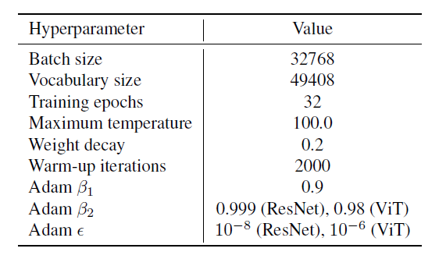

**Figure ‎11.9: Common CLIP hyperparameters**

* **Why Adam Optimizer?**

The results of the Adam optimizer are generally better than every other optimization algorithm, have faster computation time, and require fewer parameters for tuning. Because of all that, Adam is recommended as the default optimizer for most of the applications.

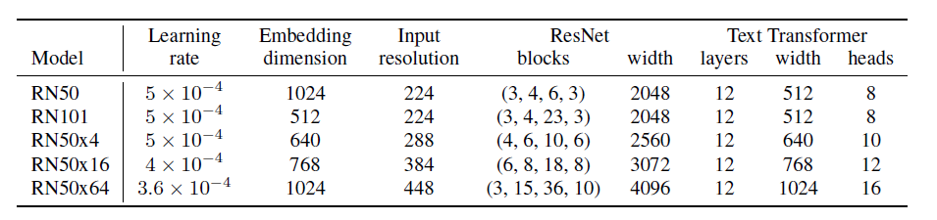

**Figure ‎11.10: CLIP-ResNet hyperparameters.**

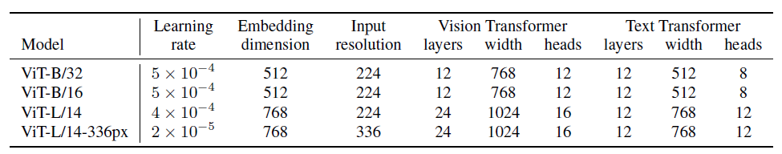

**Figure ‎11.11: CLIP-ViT hyperparameters.**

## What is VQGAN+CLIP?

VQGAN+CLIP is a neural network architecture that builds upon the revolutionary CLIP architecture published by OpenAI in January 2021.

VQGAN+CLIP It is a text-to-image model that generates images of variable size given a set of text prompts (and some other parameters).

VQGAN+CLIP has launched a new wave of AI-generated artworks.

In essence, the way they work is that VQGAN generates the images, while CLIP judges how well an image matches our text prompt.

This interaction guides the generator to produce more accurate images:

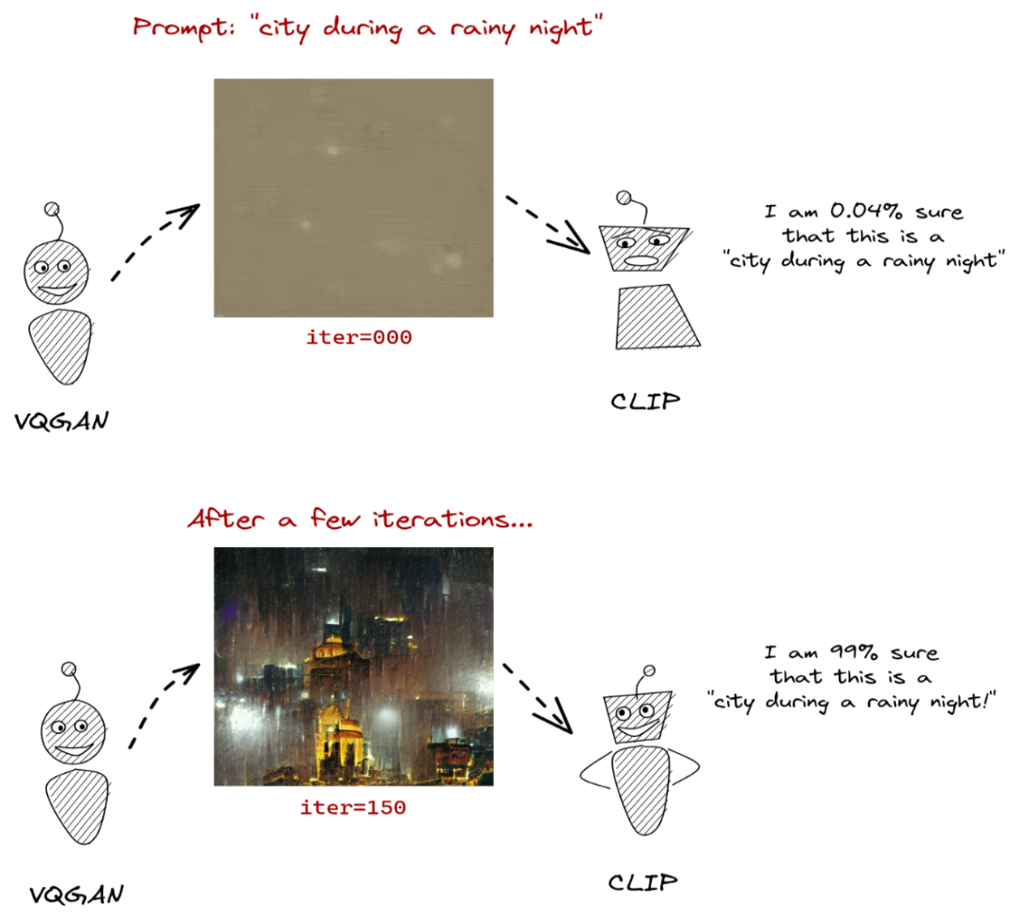

**Figure ‎11.12: The VQGAN model generates images while CLIP guides the process.**

## The Metric of our model

**We can evaluate our model by 2 methods:**

1. **Objective evaluation:** evaluation by guides the model through CLIP -score.

2. **Subjective evaluation:** human evaluation through a user evaluation.

# **Sentence Bert**

## Introduction to Sentence-Bert

* **BERT** set **new state-of-the-art performance** on various sentence classification and sentence-pair regression tasks.
* BERT uses a cross-encoder: Two sentences are passed to the transformer network and the target value is predicted.
* However, this setup is unsuitable for various pair regression tasks due **to too many possible combinations.**
* **BERT** uses cross-encoder networks that take **2 sentences** as input to the transformer network and then predict a target value.
* **BERT** can achieve **SOTA** performance on Semantic Textual Similarity tasks but both sentences must be passed through the full network.
* In a corpus consisting of **10000 sentences,** finding similar pairs of sentences requires about **50 million inference computations** taking approximately **65 hours.**
* **Sentence-BERT** impressively can provide the encodings for 10000 sentences in approximately **5 seconds!!!**
* **Sentence-BERT** finetunes a pre-trained BERT network using **Siamese** and **triplet network** structures and adds a **pooling operation** to the output of BERT to derive a fixed-sized sentence embedding vector.
* The produced embedding vector is more appropriate for sentence similarity comparisons within a vector space (i.e., that can be compared using cosine similarity)
* **SBERT** adds a **pooling operation** on top of the encoder to derive a fixed-sized sentence embedding
* CLS, **MEAN**, MAX.
* **Three objective functions:**

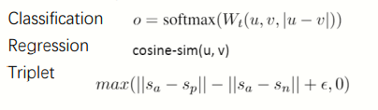 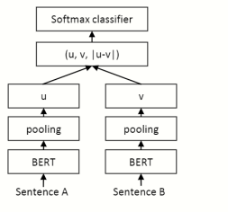

Trained on **SNLI** and Multi-Genre **NLI**

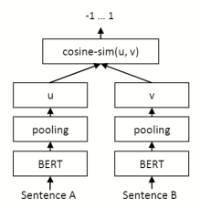

## Experiment-Semantic Textual Similarity (Unsupervised-STS)

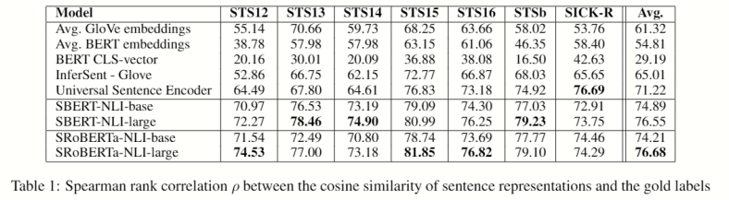

* Using the output of **BERT** leads to rather **poor performances.**
* The proposed method outperforms both InferSent and Universal Sentence Encoder substantially.
* There is a minor difference between **SBERT** and **SRoBERTa** for generating sentence embeddings.

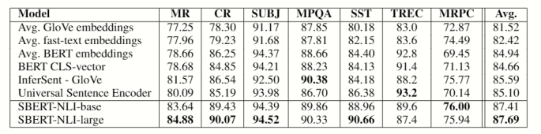

* **SBERT** can achieve the best performance in 5 out of 7 tasks.
* Even though transfer learning is not the purpose of SBERT, it outperforms other state-of-the-art sentence embeddings methods on this task
* Average BERT embeddings / CLS-token output from BERT return sentence embeddings that are infeasible to be used with cosine similarity or with Euclidean distance.

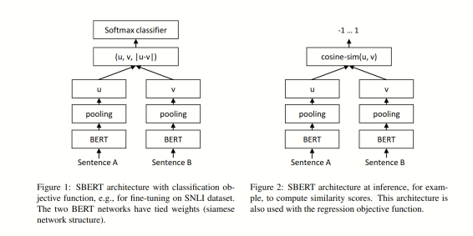

## Monolingual Sentence Embeddings Multilingual using Knowledge Distillation

* **Multilingual models** can produce tokens, and therefore in extension, sentence embeddings for multiple languages at once.
* This means that the same word or sentence, translated into different languages and processed by the model, could be assigned vector representations that aren’t similar or close in the embedding space.
* **Semantically meaningful** sentence embeddings can, and have been, generated successfully through models such as [**SentenceBERT (SBERT)**](https://arxiv.org/abs/1908.10084).
* **SBERT** is trained to generate sentence embeddings that preserve the input sequence’s semantics.
* This is achieved through **mapping** similar sentences close to each other while dissimilar ones further apart.

## The proposed knowledge distillation procedure

* Knowledge distillation enables the behavior of **one model,** referred to as the **teacher**, to be taught to another, **the student.**
* This method can in one configuration distill the knowledge of a large, possibly state-of-the-art model into a much smaller one,[***which can retain 95%+ of the teacher's performance while reducing the number of parameters with a factor of 7***](https://medium.com/dair-ai/tinybert-size-does-matter-but-how-you-train-it-can-be-more-important-a5834831fa7d)!
* It can however also be used when one model has properties, we would like to transfer onto another one, without necessarily reducing model size.
* They employ SBERT as the teacher (T) and use a multilingual model as its student (S).
* To enable the student to mimic the behavior of the teacher requires translated (parallel) sentences from one or more source languages (s) to one or more target languages (t):
  + \([(s_1, t_1), (s_2, t_2), …, (s_N, t_N)]\).
* The requirement is that **the teacher** can process the source language(s) s while the **multilingual student** can deal with the target ones t.

**The knowledge distillation training objective is constructed as follows:**

* Train the student model S so that (S(s_i) \ approx T(s_i)) and \(S(t_i) \approx T(s_i) \).
* In other words, we want the student’s sentence representations for both languages in the pair to be close to the teacher’s embedding in the source language.
* This can be achieved by **minimizing the mean-squared loss** over a mini-batch B.

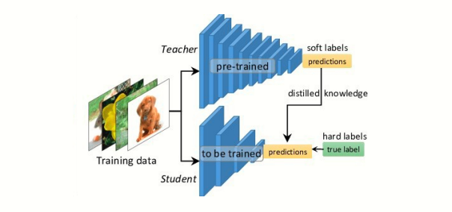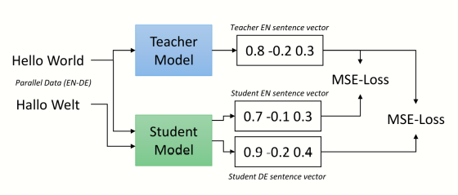

**Figure ‎12.1: Teacher-Student Model**

The **ideal student** can take what the teacher teaches and extend that knowledge beyond the teacher’s capabilities.

* The **student model** here works with the same idea.
* That means that it must be capable of functioning with different languages

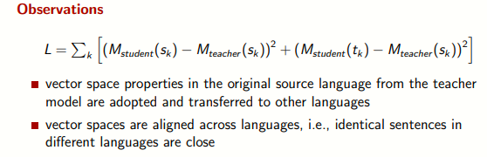

## Multilingual Joint Image & Text Embeddings

* [Sentence Transformers](https://www.sbert.net/) can be used to map images and texts to the same dense vector space.
* The model uses the [OpenAI CLIP Model](https://github.com/openai/CLIP), which was trained on a large set of images and image alt texts.
* The original CLIP Model only works for English, hence, we used [Multilingual Knowledge Distillation](https://arxiv.org/abs/2004.09813) to make this model work with 50+ languages.
* This model can be used for image search (users search through a large collection of images) and for **multilingual zero-shot** image classification (image labels are defined as text).

## Training

* This model has been created using [**Multilingual Knowledge Distillation**](https://arxiv.org/abs/2004.09813)**.**
* **As a teacher model,** we used the original **clip-ViT-B-32** and then trained a [**multilingual DistilBERT**](https://huggingface.co/distilbert-base-multilingual-cased)model **as a student** model.
* Using parallel data, the multilingual student model learns to align the teachers' vector space across many languages.
* The image encoder from CLIP is unchanged, i.e., we can use the original CLIP image encoder to encode images.

# **Create video:**

1. Split text into sentences and run model with the same number of the sentences to produces image for each sentence
2. The final image produced after 200 steps; the 200 steps are the numbers of tryers which the model did to produce well image
3. Then we add each final image of each sentence in the same folder called “images”
4. then we Write each sentence (with any language) to its generated image
5. then we collect all the images that written on it to folder called “images_texts”
6. then we used speech model (from text to speech), we enter our text (with any language) as the input to the model and then produce an audio
7. then we create a video that contain image from “images_texts” folder and its audio for each image and save it in a folder called “videos”
8. then finally concatenate the videos to one video.

# **Next Step**

* We plan to design a simple application that uses this model to make its use easier, faster, and available to everyone.
* Also, we plan to investigate whether the quality of images can be improved by using other attention mechanisms during generation to get higher image quality.

# **References**

* A beginner's guide to the clip model. KDnuggets. (n.d.). Retrieved March 5, 2022, from https://www.kdnuggets.com/2021/03/beginners-guide-clip-model.html
* Conneau, A., Khandelwal, K., Goyal, N., Chaudhary, V., Wenzek, G., Guzmán, F., ... & Stoyanov, V. (2019). Unsupervised cross-lingual representation learning at scale. arXiv preprint arXiv:1911.02116.
* Daniel Nelson. (2020, October 5). What is a Generative Adversarial Network (GAN)?]. Retrieved from <https://www.unite.ai/what-is-a-generative-adversarial-network-gan/>
* Devlin, J., Chang, M. W., Lee, K., & Toutanova, K. (2018). Bert: Pre-training of deep bidirectional transformers for language understanding. arXiv preprint arXiv:1810.04805.
* Esser, Patrick & Rombach, Robin & Ommer, Björn. (2020). Taming Transformers for High-Resolution Image Synthesis.
* Frolov, V. (2021, January 14). Clip from OpenAI: What is it and how you can try it out yourself. Хабр. Retrieved March 6, 2022, from https://habr.com/ru/post/537334/
* Jakub Langr and Vladimir Bok (September 2019). GANs in Action: Deep learning with Generative Adversarial Network.
* Liu, Y., Ott, M., Goyal, N., Du, J., Joshi, M., Chen, D., ... & Stoyanov, V. (2019). Roberta: A robustly optimized Bert pretraining approach. arXiv preprint arXiv:1907.11692.
* Nils Reimers, Iryna Gurevych (2019). Sentence-BERT: Sentence Embeddings using Siamese BERT-Networks. DOI: <https://arxiv.org/abs/1908.10084>
* Reimers, N., & Gurevych, I. (2019). Sentence-Bert: Sentence embeddings using siamese Bert-networks. arXiv preprint arXiv:1908.10084.
* Sergios Karagiannakos. (2022, March 3). *Vision language models: Towards multi-modal Deep learning*. AI Summer. Retrieved March 6, 2022, from https://theaisummer.com/vision-language-models/
* Shariatnia, M. (2021, April 7). *Simple implementation of OpenAI Clip Model: A tutorial*. Medium. Retrieved March 6, 2022, from https://towardsdatascience.com/simple-implementation-of-openai-clip-model-a-tutorial-ace6ff01d9f2
* Pires, T., Schlinger, E., & Garrette, D. (2019). How multilingual is multilingual BERT? arXiv preprint arXiv:1906.01502.
* Yang, Y., Cer, D., Ahmad, A., Guo, M., Law, J., Constant, N., ... & Kurzweil, R. (2019). Multilingual universal sentence encoder for semantic retrieval. arXiv preprint arXiv:1907.04307.
* What are Diffusion Models? Lilian Weng. Retrieved July 11, 2021, from https://lilianweng.github.io/posts/2021-07-11-diffusion-models/
* Generative Modeling by Estimating Gradients of the Data Distribution. Yang Song. Retrieved May 5, 2021 , from

https://yang-song.github.io/blog/2021/score/

* Diffusion Models Made Easy . J. Rafid Siddiqui, PhD. Retrieved May 2, 2022 , from <https://towardsdatascience.com/diffusion-models-made-easy-8414298ce4da>
* Improving Diffusion Models as an Alternative To GANs, Part 1. Arash Vahdat and Karsten Kreis. Retrieved Apr 26, 2022, from

https://developer.nvidia.com/blog/improving-diffusion-models-as-an-alternative-to-gans-part-1/

* Improving Diffusion Models as an Alternative To GANs, Part 2. Arash Vahdat and Karsten Kreis. Retrieved Apr 26, 2022, from

<https://developer.nvidia.com/blog/improving-diffusion-models-as-an-alternative-to-gans-part-2/>

* Introduction to autoencoders. JEREMY JORDAN. Retrieved MAR 19, 2018, from

<https://www.jeremyjordan.me/autoencoders/>

* Intuitively Understanding Variational Autoencoders. Irhum Shafkat. Retrieved Feb 4, 2018, from

<https://towardsdatascience.com/intuitively-understanding-variational-autoencoders-1bfe67eb5daf>

* Flow-based Deep Generative Models. Lilian Weng. Retrieved October 13, 2018, from

https://lilianweng.github.io/posts/2018-10-13-flow-models/